Step1: Login to <https://portal.azure.com> and create a new Azure Web App with name “fcvmapi” in resource group “fc3TierVnetResourceGroup”. Settings are shown below.

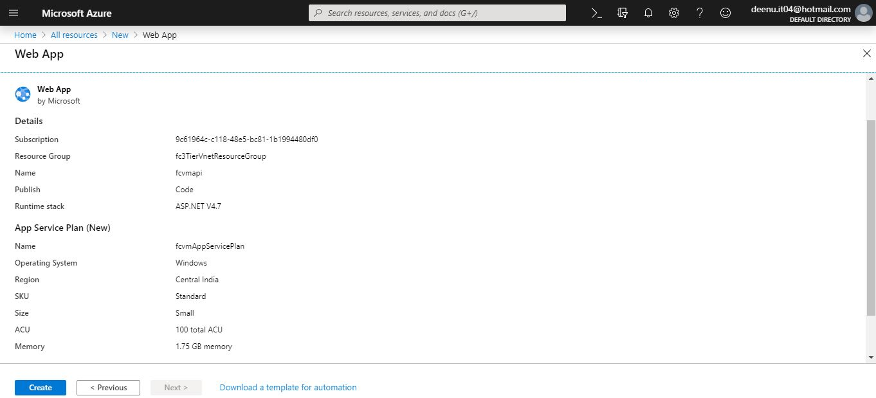

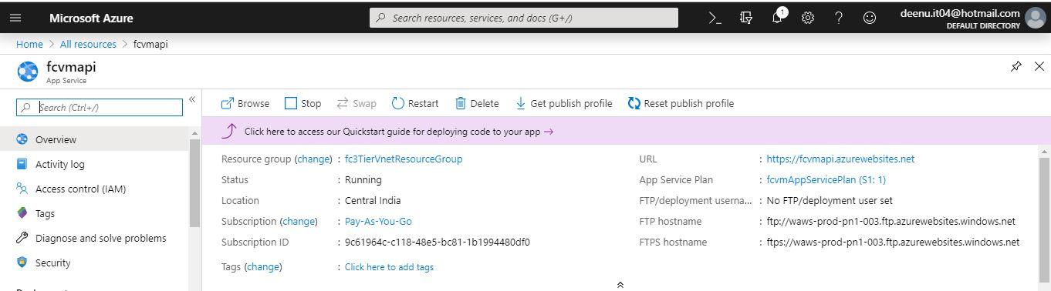

Step2: Enable authentication and authorization for Api App

1. From the left menu, select Authentication / Authorization, then enable App Service Authentication by selecting On.
2. In Action to take when request is not authenticated, select Log in with Azure Active Directory.
3. Under Authentication Providers, select Azure Active Directory

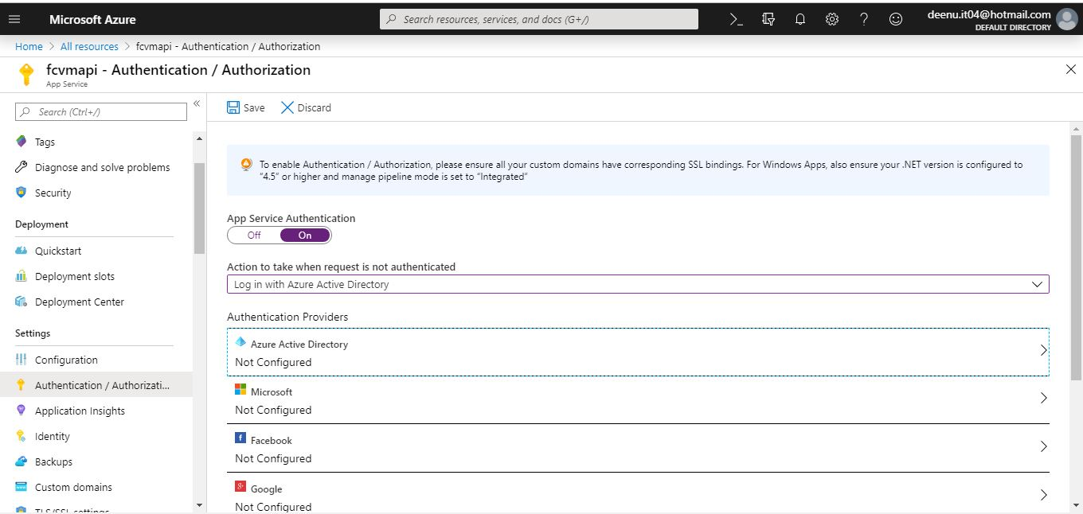

1. Select Express and accept the default settings to create a new AD app and select OK.

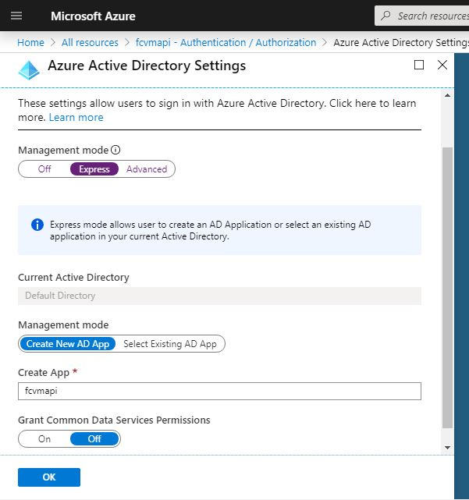

1. In the Authentication / Authorization page, select Save.
2. Select Azure Active Directory again, and then select the Azure AD App.

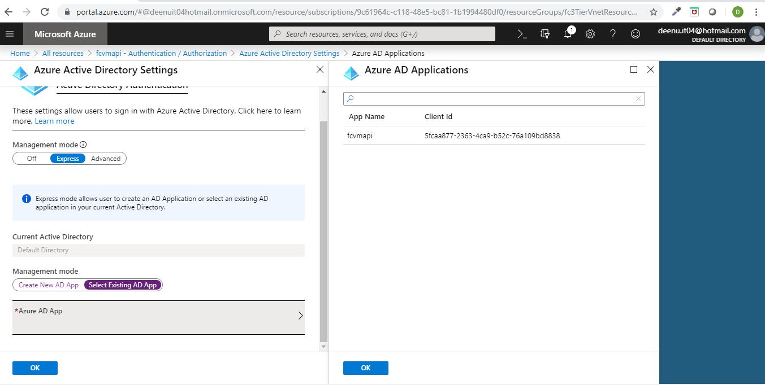

1. Copy the Client ID of the Azure AD application to a notepad.

Step5: Create a Client secret for fcvmapi AAD app.

1. Go to Azure Active Directory -> App registrations.

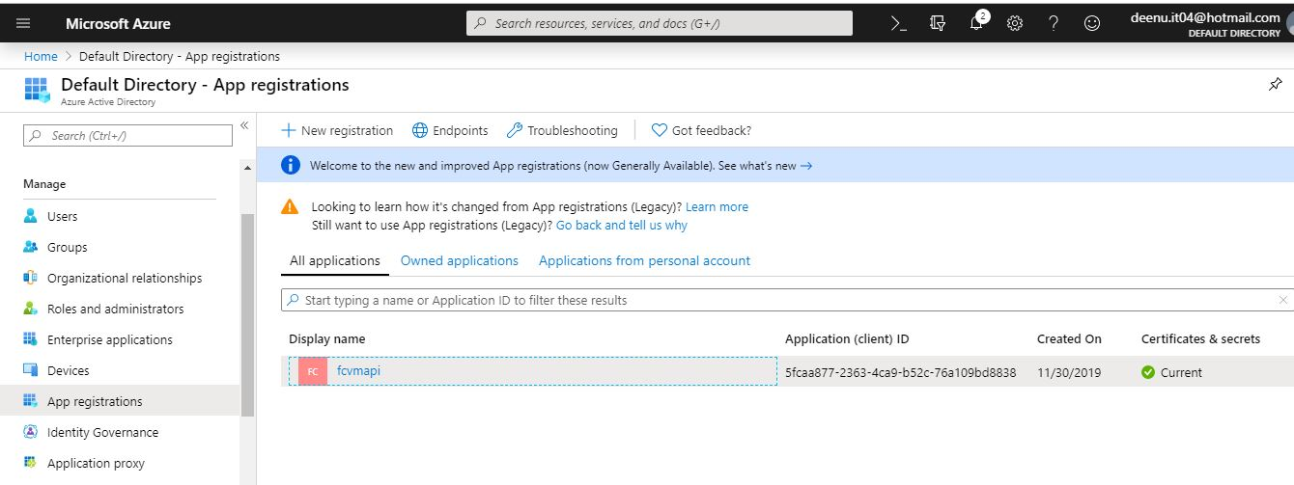

1. Select **fcvmapi** AAD app. Copy Client ID and Tenant ID to notepad.

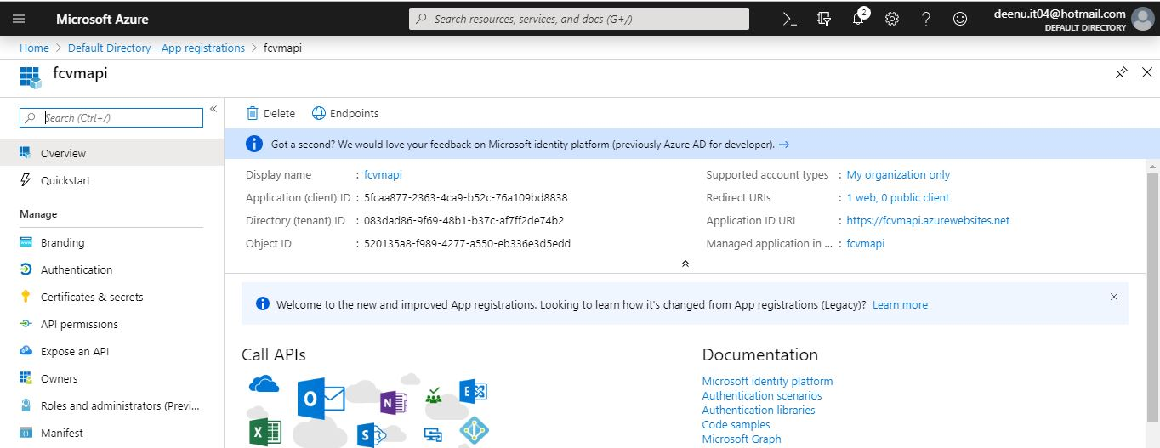

1. From the left menu select Certificates & secrets. Then under Client secrets click **New client secret**.

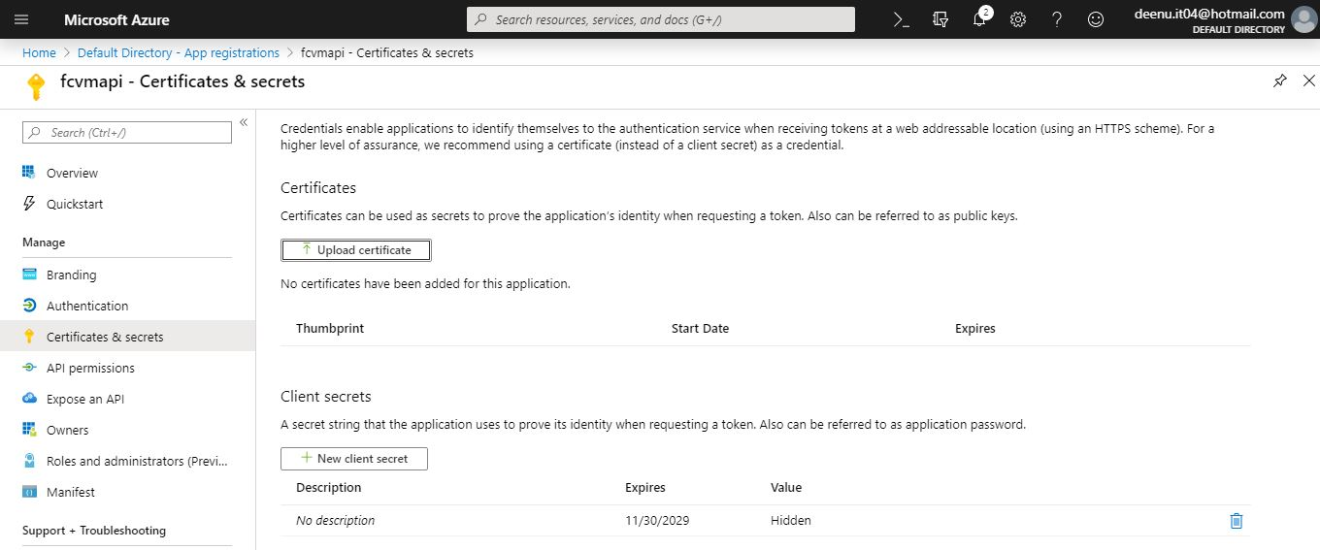

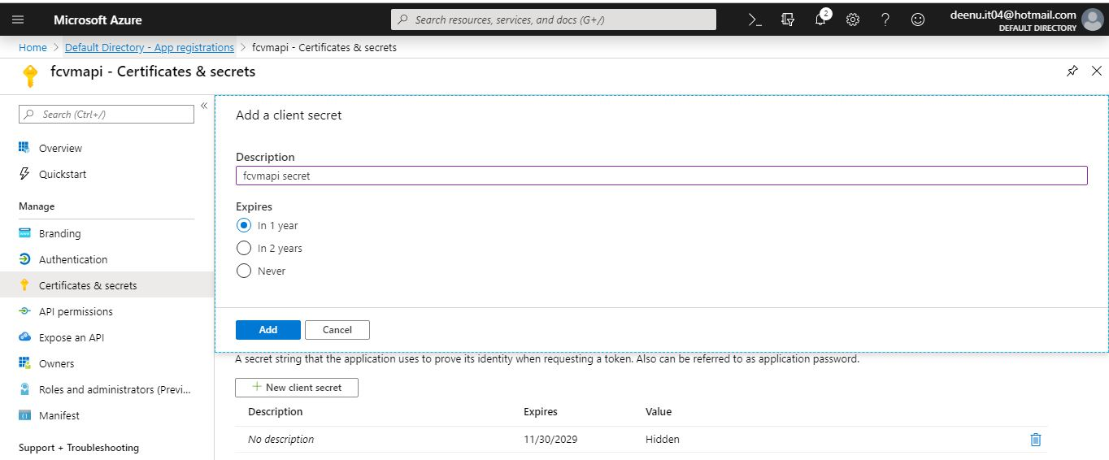

1. Copy the new client secret to notepad.

Step6: Assign service principal permissions to scope **fc3TierVnetResourceGroup** resource group.

1. Select **fc3TierVnetResourceGroup** resource group. Then from the left menu select Access Control (IAM) and then click Add role assignment.
2. Choose API Management Service Contributor role for fcvmapi and click Save.

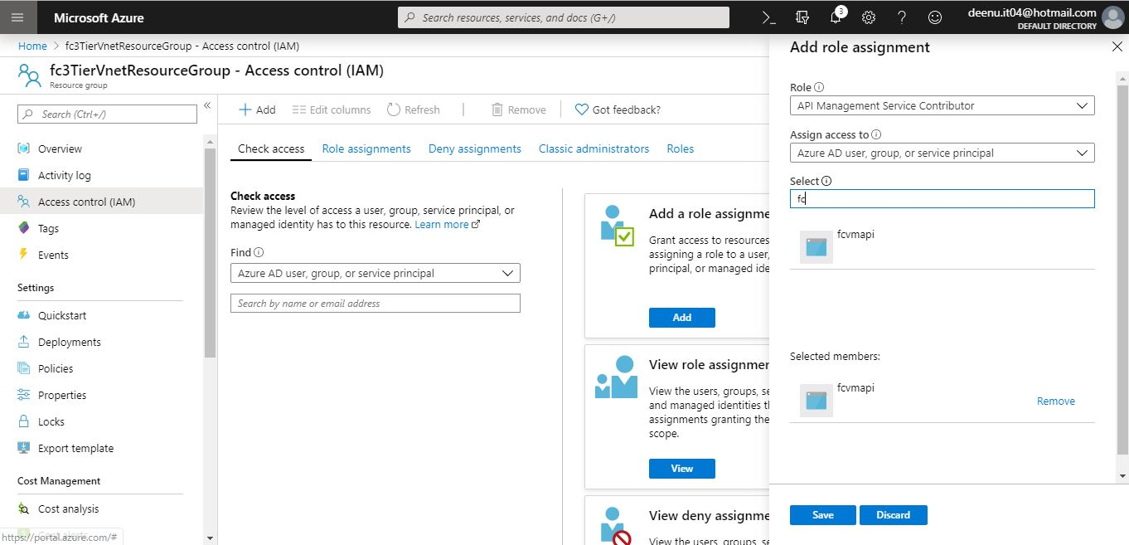

Step7: Open the **ManageAzureVMApi** project in Visual Studio.

1. Add the Subscription ID, Tenant ID, Client ID and Client Secret in Web.config file.
2. Include front end app url <https://fcvmapp.azurewebsites.net> in CORS origins list.
3. Then publish the Web API in Azure using Visual Studio Web Deploy. Publish profile information can be downloaded from azure portal.

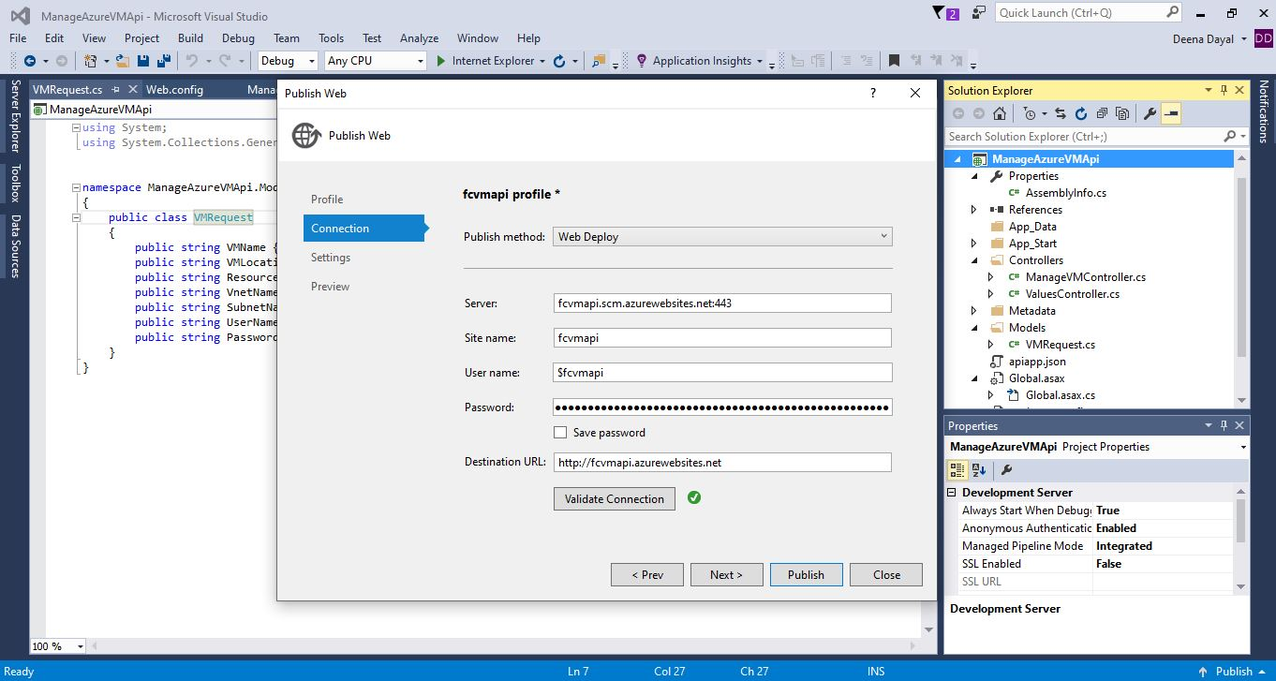

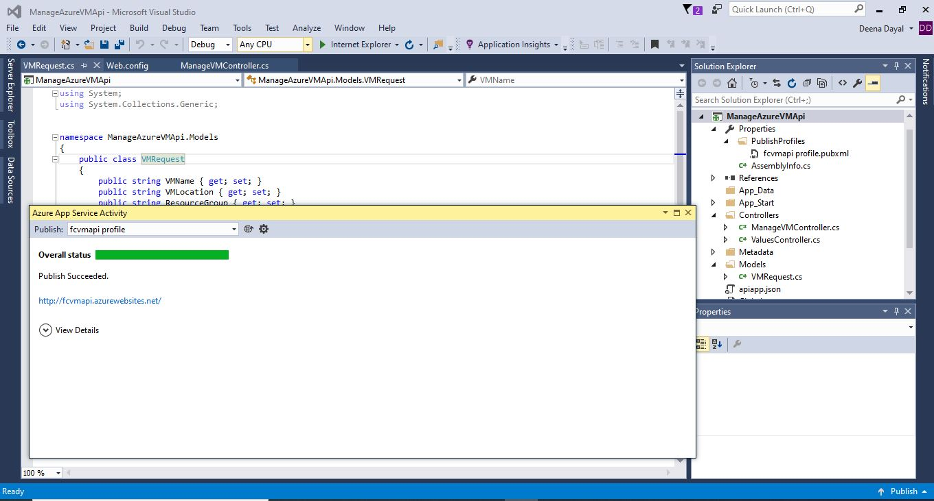

Step8: Configure API Definition Url in Web Api settings.

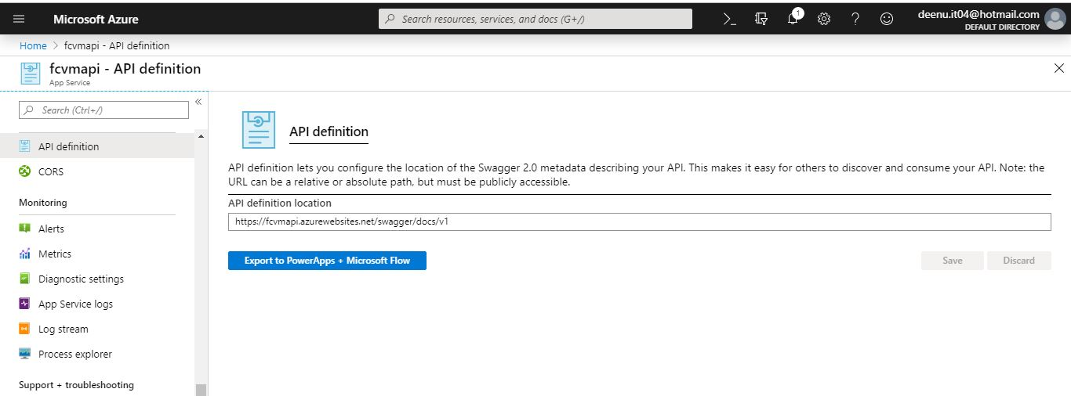

Step9: Verify the API app using Swagger UI

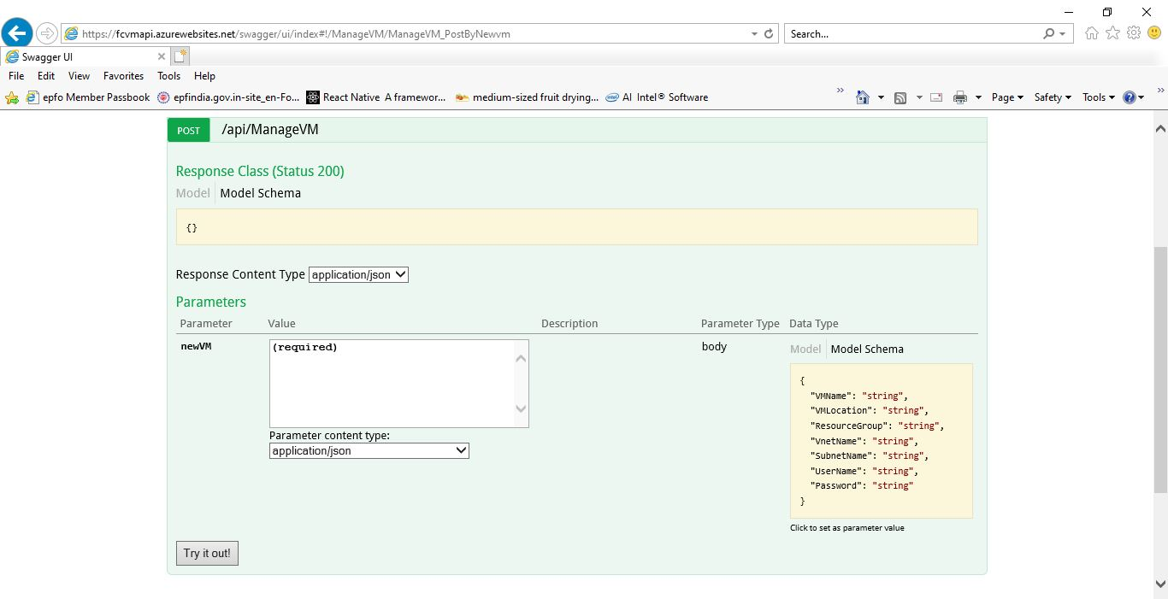

Step: Configure CORS in API app.

